

**PROJECT  
MANAGEMENT PLAN**

**Hanoi, June 3rd, 2020**

**Table of Contents**

**Chapter 2: Project Plan** ***4***

**2.1. Project Definition** ***4***

***2.1.1.*** ***FPT Education Recruitment System***

***2.1.2.*** ***Problem Abstract 4***

***2.1.3. Project Overview 4***

***2.1.3.1. The Current System 4***

***2.1.3.2. The Proposed System 4***

***2.1.3.3. Boundaries of the System 4***

***2.1.3.4. Development Environment 4***

**2.2. Project Organization** ***5***

***2.2.1. Software Process Model*** ***5***

***2.2.2. Roles and Responsibilities*** ***7***

***2.2.3. Tools and Techniques*** ***8***

**2.3. Project Management Plan** ***9***

***2.3.1. Tasks*** ***9***

***2.3.3. All Meeting Minutes*** ***10***

**2.4. Coding Convention** ***11***

**2.5. Other material** ***11***

# **Project Plan**

## **Project definition**

### ***Problem abstract*** FPT education has grown 40% per year so FPT education human recruitment increases rapidly. Therefore, FERS helps HR:

### Post recruitment on [website](https://fpt.edu.vn/tuyen-dung).

* Receive CVs from email and the following jobs manual doing by excel.

tăng trưởng 40% 1 năm => nhu cầu tuyển dụng tăng mạnh.

HR post tin tuyển dụng lên fpt.edu.vn/tuyen-dung

Nhận CV qua email, toàn bộ cồng việc tiếp theo làm manual bằng excel

* + 1. ***Project overview***
       1. ***Current system***

Currently, FPT education system implements the following recruitment channels:

* Website [fpt.edu.vn](https://fpt.edu.vn/tuyen-dung)
* Social network

Linkin: [https://www.linkedin.com/company/fpt-education](https://www.linkedin.com/company/fpt-education/?fbclid=IwAR39GEoELUVWs8eSbrAiO8OE8CzoKNysQxtNqCuNjcyQGKgILS-hR5X5fTY)

* Advertisement

Facebook: <https://www.facebook.com/educationfpt/>

Youtube: <https://www.youtube.com/user/FPTUniversityChannel>

* + - 1. ***The proposed system***
* We create a system to allow people to search and apply CV to remaining FPT Education’s jobs. Besides, candidates who are accepted on a job can do a test online.
* Recruitment Staff can manage CVs, accounts, jobs and a few data at Home Page on system.
  + - 1. ***Boundaries of the system***
* Allow candidates to view and search information about FPT education system, recruitment jobs, recruitment process.
* Allows candidates to create, upload, edit CV to apply job
* Allows candidates to do a small quiz to learn more information about FPT Education
* Allows HR Staff to manage uploaded CV of candidate, add, edit, delete Job
* Allows System administrators to manage users, system config, manage location, manage units of FPT Education.
  + - 1. ***Environment development***
* ASP .NET MVC 5

## **Project organization**

### ***Software process model***

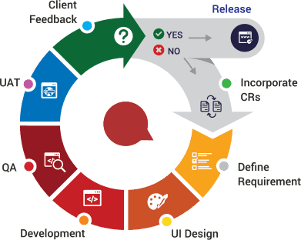

*Figure 2.1 – Agile Software Process Model*

FPT Education Recruitment System project uses the Agile Software Process Model.

The Agile model was primarily designed to help a project to adapt to change requests quickly. So, the main aim of the Agile model is to facilitate quick project completion. To accomplish this task agility is required. Agility is achieved by fitting the process to the project, removing activities that may not be essential for a specific project. Also, anything that is wastage of time and effort is avoided. Also, this model has these useful advantages:

* Customer satisfaction by rapid, continuous delivery of useful software.
* People and interactions are emphasized rather than process and tools. Customers, developers and testers constantly interact with each other.
* Working software is delivered frequently (weeks rather than months).
* Face-to-face conversation is the best form of communication.
* Close, daily cooperation between business people and developers.
* Continuous attention to technical excellence and good design.
* Regular adaptation to changing circumstances.
* Even late changes in requirements are welcomed

### ***Roles and responsibilities***

#### **Organization structure**

|  |  |
| --- | --- |
| **Role** | **Responsibilities** |
| Project Manager | Planning, developing schedules, coordinating communication, generally responsible for keeping the team’s focus on the main goal. |
| Technical Leader | Responsible for choosing and deciding what technologies should be used, as well as for overseeing the work being done by other developers. |
| Quality Assurance Manager | Ensuring the product meets the certain standards of quality from requirements. |
| Test Leader | Responsible for test execution, including test set-up and test run, evaluation of test run and error recovery, defect logging and test results recording. |
| Developer | Involve in coding the product and reviewing code of other developers. |
| Designer | Involve in designing the product’s user interface. |
| Tester | Involve in testing the product. |

*Table 2.1 – Project organization structure*

#### **Project team members**

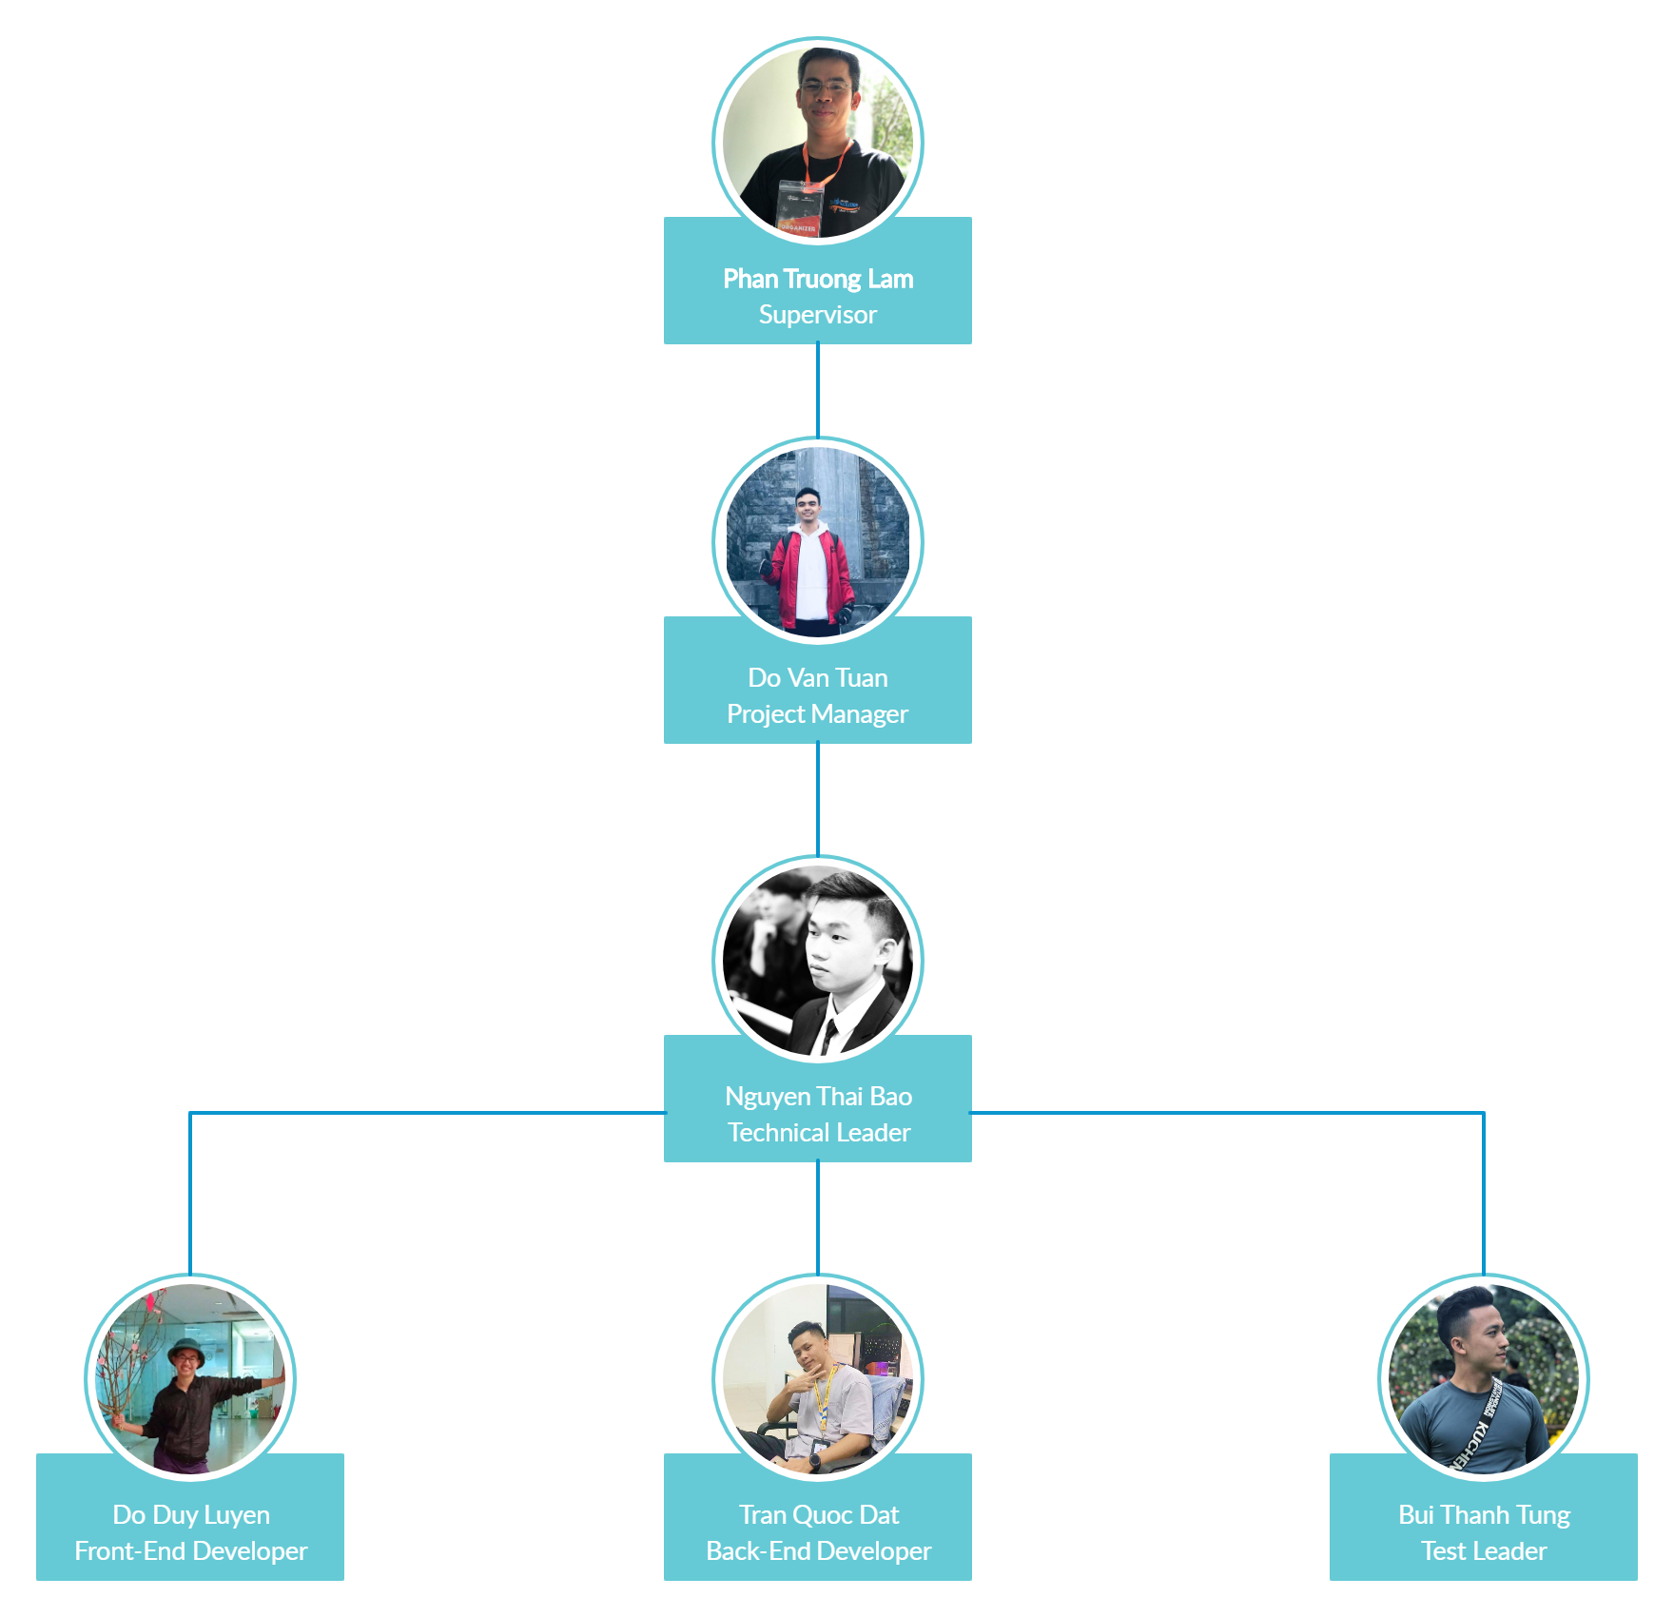

*Figure 2.2 – Project team member tree*

|  |  |
| --- | --- |
| **Team Member** | **Role** |
| Pham Truong Lam | Supervisor |
| Do Van Tuan | Project Manager, Back-End Developer |
| Nguyen Thai Bao | Technical Leader, Developer, Tester, Quality Assurance Manager |
| Do Duy Luyen | Front-End Developer, Tester, Designer |
| Tran Quoc Dat | Back-End Developer, Tester |
| Bui Thanh Tung | Test Leader, Front-End Developer, Business Analyst |

*Table 2.2 – Project role description*

### ***Tools and techniques***

|  |  |
| --- | --- |
| **Category** | **Tools & techniques** |
| Programming languages & runtime | C#, Javascript |
| Frameworks | .Net MVC 4.5 |
| Software architecture | MVC |
| Operating system | macOS 10.16 Catalina, Window 10 |
| Version control | GitHub, Git 2.27.0 |
| IDE/Editors | Visual Studio 2017 |
| UML tools | Draw.io |
| DBMS | SQL Server Management System 2012 |
| Project management tools | Pivotal Tracker, Microsoft Excel 2016 |
| Document tools | Microsoft Office 2016 |
| Process model | Agile Software Process Model |
| Development process | Continuous Integration & Continuous Delivery |
| Communication tools | Facebook, Gmail, Slack, Skype |
| Files management tools | Google Drive |
| Testing tools | NUnit, Postman 6.5.2 |

*Table 2.3 – Tools & techniques used in project*

## **Project management plan**

### ***Tasks***

Refer to [***Project management plan.xlsx***](https://docs.google.com/spreadsheets/d/1ywuEWK_owP92odx_iZhE12ZZXCZRW3csHZBICMr2HCM) file.

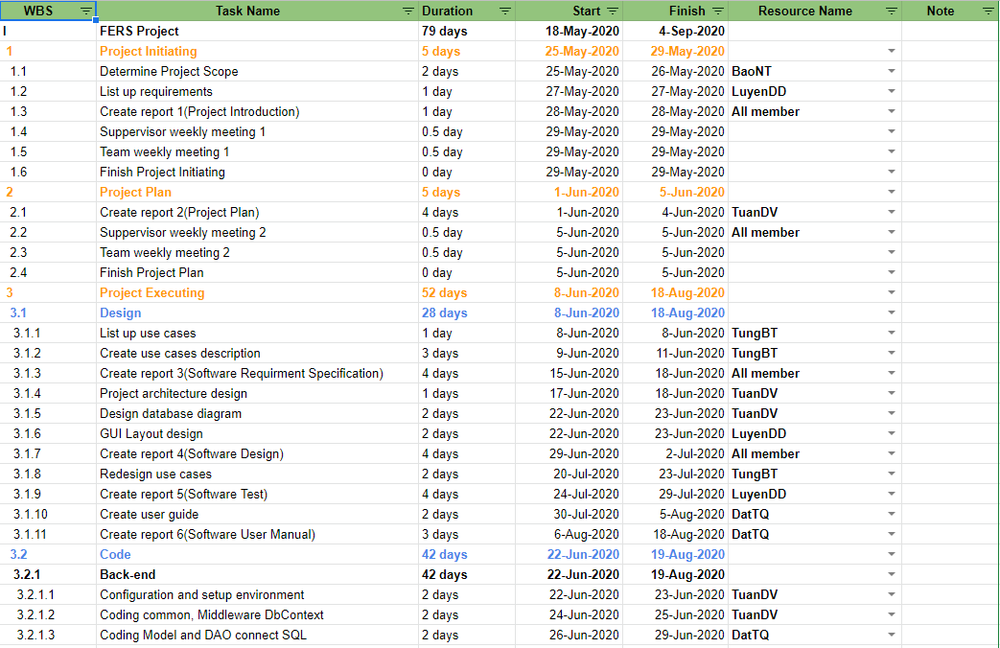

*Figure 2.3 – Project management plan*

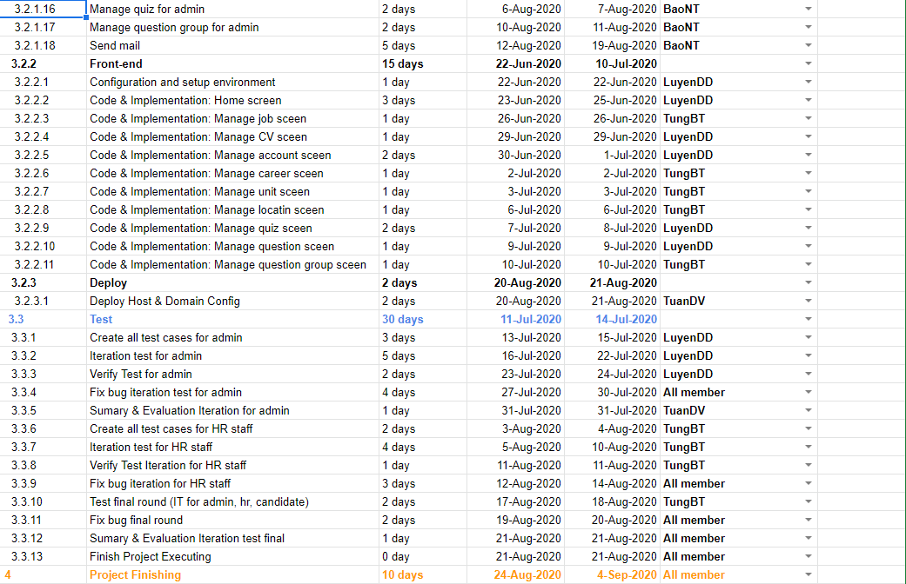

*Figure 2.4 – Project management plan*

### ***Meeting minutes***

All meeting minutes will be written following this template:

|  |  |  |  |  |  |
| --- | --- | --- | --- | --- | --- |
| ***Meeting/Project Name:*** | ***FPT Education Recruitment System*** | | | | |
| ***Date of Meeting:*** | *05/28/2020* | | ***Time: (Type)*** | *2 hours (Face-to-face)* | |
| ***Meeting Called by:*** | *TuanDV* | | ***Location:*** | *R107 – Alpha building* | |
| ***Note Taker:*** | *LuyenDD* | | ***Time Keeper:*** | *TungBT* | |
| **1. Meeting Objective** | | | | | |
|  | | | | | |
| **2. Attendance** | | | | | |
| ***Name*** | ***Roles*** | ***E-mail*** | | | ***Phone*** |
| Do Van Tuan | Project Manager | [tuandvse05339@fpt.edu.vn](mailto:tuandvse05339@fpt.edu.vn) | | | 0868455987 |
| Do Duy Luyen | Developer | [luyenddse04999](mailto:luyenddse04999@fpt.edu.vn)[@fpt.edu.vn](mailto:quanghdse03459@fpt.edu.vn) | | | 0383551655 |
| Nguyen Thai Bao | Developer | [baontse05601](mailto:baontse05601@fpt.edu.vn)[@fpt.edu.vn](mailto:phanlhse04195@fpt.edu.vn) | | | 0353754567 |
| Tran Quoc Dat | Developer | [dattqse05715](mailto:dattqse05715@fpt.edu.vn)[@fpt.edu.vn](mailto:thanhpkse04131@fpt.edu.vn) | | | 0888833324 |
| Bui Thanh Tung | Tester | [tungbtse05661](mailto:tungbtse05661@fpt.edu.vn)[@fpt.edu.vn](mailto:tungtbse06187@fpt.edu.vn) | | | 0354442626 |
| **3. Tasks Done** | | | | | |
|  | | | | | |
| **4. To-Do Tasks** | | | | | |
|  | | | | | |
| **5. Difficulty** | | | | | |
|  | | | | | |

*Table 2.4 – Meeting minute template*

### **Coding convention**

Coding and implementing the FERS uses StyleCop[1] analyzes C# source code to enforce a set of style and consistency rules with .Net on Visual Studio 2017. The rules are classified into the following categories:

1. Documentation
2. Layout
3. Maintainability
4. Naming
5. Ordering
6. Readability
7. Spacing

### **Other materials**

1. StyleCop: <https://en.wikipedia.org/wiki/StyleCop>